Youth Engagement and Empowerment Project Initiation Plan

Final Progress Review Report

Implementing Partner: | United Nations Development Programme
Responsible Party: | United Nations Development Programme
Atlas Award ID:  Atlas Project ID:  Project Title: | 00128569  00122529  Youth Engagement and Empowerment (Project Initiation Plan)
Project Duration: | 18 months
Project Budget (AWP): | 1,438,043USD
Funding Partners / Donors:  Reporting: Period: | Arab Youth Center, UAE  1st July 2020 – 31st December 2021  18 Months
Contact Person/s: | Linda.haddad@undp.org

Table of Contents

- Executive Summary 4
- Introduction 5
- Progress Review: Key Activities and Results, 1st July – 31st December 6
- Key Challenges, Lessons Learned and Recommendations 19
- Update on risks and mitigation measures 20
- Partnerships and Sustainability 21
- Financial Summary 22

Acronyms

AYC  ILO  UNDP  RBAS  UNICEF  YDD  YLP  YSO  TBHF  DAPP | Arab Youth Center  International Labour Organization  United Nations Development Programme  Regional Bureau for Arab States  United Nations Children's Fund  Youth Development Delegates  Youth Leadership Programme  Youth Serving Organization  The Big Heart Foundation  Danish-Arab Partnership Programme

- Executive Summary

Building on the success and momentum of the Youth Leadership Programme, UNDP’s Regional Bureau for Arab States initiated the development of a holistic, comprehensive, and more impactful youth project, that aims to utilize innovation, portfolio approach and leverage existing and new partnerships in order to support youth of the Arab region in fulfilling their potential and contributing to achieving Agenda 2030. Over the period of 18 months the team has conducted consultations, produced theory of change, and drafted a project document.

The programme’s work contributes to Outcomes 1 and 2 of UNDP RBAS (2018-2021): Outcome 1: Accelerate structural transformation of productive capacities in a sustainable and inclusive manner and 2) Strengthen institutions to promote inclusive participation, prevent conflict and build peaceful societies. The project has the following specific output that focuses on strengthening capacities and participation of youth in the region: Regional platforms for policy dialogue enabled to support civic engagement, constitution-making, electoral and parliamentary processes and institutions to promote inclusion, transparency and accountability (RBAS Regional Programme Document, Output 2.2.2) This output (2.2.2) was realized through strengthening the capacity and skills of youth participants, by providing capacity-building, creating an environment enabling them to become effective leaders, thinkers, innovators, and change-makers, as well as consolidating and expanding the network of youth-serving partner organizations to strengthen the ecosystem for youth-led innovation for development in the Arab region.

The design and implementation were severely affected by the COVID-19 pandemic that forced lockdowns, closures of workplaces, schools, and public places globally in March 2020. In the Arab region, all countries participating in UNDP youth programming had to move and adapt to an online training delivery in a very short period of time, affecting the ability to reach all target groups. Due to low connectivity issues, the unpredictability of internet connection and lack of access to electronic devices across the Arab region has led to delays in programme delivery as well as the inability of all interested youth to participate, vastly reducing the number of participants compared to previous years. Many countries adopted a new modality of service delivery, moving completely online and utilizing innovative digital tools to engage the youth participants. In order to mitigate this situation, online training for Youth Focal Points and partner youth-serving organizations was provided by the Regional Youth Team.

However, despite the challenges, Youth Engagement and Empowerment Programme Project initiation plan has managed to deliver a number of key activities related to youth and partner capacity strengthening, regional communication campaigns, virtual events, competitions, and Country Offices support, in addition to new project development processes, resource mobilization efforts and partnership forging.

Also, the additional human capacity of the designated Youth Development Delegates has significantly improved the quality of youth programming on the ground through regular reporting, creation of context-specific solutions, cross-border collaboration, and close coordination of activities. It is highly recommended to continue the partnership with the Arab Youth Center in order to keep the Youth Development Delegates to support high-quality youth programming at country-office level. Furthermore, a dedicated, context-specific technical support to Youth Teams in Country Offices offered by designated staff of Regional Youth Team assured relevance, consistency and efficient adaptability resulting in improved youth programming on the ground. Finally, in order to develop a sound project for youth empowerment in the Arab region, investment was required by the Bureau to support the process, going forward it is recommended that intensive resource mobilization efforts help secure funding of external donors. The 18 months of the initiation plan have been a huge learning experience and all recommendations stem directly from the challenges faced by the Regional Youth Team, Youth Focal Points, Youth Development Delegates, partner youth-serving organisations and the youth participants.

- Introduction

Over the last six years, the Regional Bureau for Arab States has increasingly invested in youth programming to strengthen the organization’s approach to supporting, enabling, engaging, and empowering young people to lead the change they want to see in their near future as change makers. The Youth Leadership Programme (YLP), the activity the Youth Engagement and Empowerment Project (YEEP) is building on, was first started under the regional project Mosharaka. There was a dedicated output for YLP and in December 2018 Mosharaka was closed with YLP becoming a separate component. Opportunities, challenges, gaps and lessons learned have been observed and assessed, paving the way for the development of a more holistic Youth Programme. This initiation phase was for the development of the Bureau’s regional project which aims to build on the successes of the previous years’ achievements, however, this time through an innovative approach that contributes to more impact and support to the young people in the Arab Region.

The programme’s work contributes to Outcomes 1 and 2 of UNDP RBAS (2018-2021): Outcome 1: Accelerate structural transformation of productive capacities in a sustainable and inclusive manner and 2) Strengthen institutions to promote inclusive participation, prevent conflict and build peaceful societies. The project has the following specific output that focuses on strengthening capacities and participation of youth in the region: Regional platforms for policy dialogue enabled to support civic engagement, constitution-making, electoral and parliamentary processes and institutions to promote inclusion, transparency and accountability (RBAS Regional Programme Document, Output 2.2.2)

This output (2.2.2) was realized through strengthening the capacity and skills of youth participants, by providing capacity-building, creating an environment enabling them to become effective political and civic leaders, thinkers, innovators, and change-makers, as well as consolidating and expanding the network of youth-serving partner organizations to strengthen the ecosystem for youth-led innovation for development in the Arab region.

The project is managed by a team comprised of a Regional Project Manager, two Youth UN Volunteers and two IPSA consultants. Additionally, a group of 10 Youth Development Delegates assisted with the delivery of the programme on the national level, coordinated by a Youth Delegates based within the Regional Team at the Hub in Amman. The team is responsible for: providing technical and strategic support to the project’s national partners and counterparts; monitoring progress achieved against main objectives; organizing regional events; resource mobilization and donor engagement, communications and coordinating efforts to scale up the programme and its reach.

Stakeholders include national and regional civil society organizations, NGOs, youth-serving organizations, national governments, Arab Youth Center, other UN agencies and donors, academic institutions/universities, and the private sector.

The programme is monitored through submission and review of National Action Plans by each Country Office, Annual Final Report, regular calls with appointed Youth Focal Points and Youth Development Delegates (YDD) in Country Offices to follow-up on the progress of activities taking place on the ground, collecting feedback from the youth participants and youth-serving organizations during the Regional Forum and by following and tracking the progress and success of YLP Alumni across the region. Additional quarterly reports were submitted by the YDDs as part of their assignment.

- Progress Review: Key Activities and Results, 1st July 2020 – 31st December 2021

Section 1: Overall progress against outcomes

Lasting 18 months the initiation phase of the YEEP, aimed to build on the successes of the previous years’ achievements of the Youth Leadership Programme, by taking on a new, innovative approach that contributes to more impact and support to the young people in the Arab Region. The interventions delivered over the years (2015-2020) have been activity-based, and a need for a holistic approach that ensures quality control, consistency in our programme offer and clear monitoring and evaluation tools for sustained impact has been identified. Therefore, in the initiation phase, it is vital to transform the gains achieved over the last 5 years into a project that sustains and increases regional support for better youth programming.

As such, the programme’s work contributes to Outcomes 1 and 2 of UNDP RBAS (2018-2021): Outcome 1: Accelerate structural transformation of productive capacities in a sustainable and inclusive manner and 2) Strengthen institutions to promote inclusive participation, prevent conflict and build peaceful societies. The project has the following specific output that focuses on strengthening capacities and participation of youth in the region: Regional platforms for policy dialogue enabled to support civic engagement, constitution-making, electoral and parliamentary processes, and institutions to promote inclusion, transparency, and accountability (RBAS Regional Programme Document, Output 2.2.2)

Over the reporting period youth programming was delivered in 16 countries (Algeria, Bahrain, Djibouti, Egypt, Iraq, Jordan, Lebanon, Libya, Morocco, Palestine, Saudi Arabia, Somalia, Sudan, Syria, Tunisia, and Yemen) engaging around 4,000 young people to enhance their knowledge on social innovation, SDGs, Emotional Intelligence, leadership, and political and civic participation, by successfully partnering with over 45 youth-serving organizations. As a result, around 170 (over the 18-month period) innovative youth-led solutions to address communities’ needs were developed, contributing to transforming their productive capacities in a sustainable and inclusive manner.

Additionally, the technical capacity of national partner youth-serving organizations to deliver youth programming and SDG implementation on the ground was strengthened through context-tailored support and training, delivered by technical experts from the Regional Hub, YLP partners and stakeholders, external experts and speakers on topics such as virtual facilitation, digital wellbeing, emotional intelligence and leadership skills, gender equality, climate change, political and civic participation, SDG implementation and Design Thinking.

Furthermore, building on introduction of Political and Civic Participation area of focus in 2019, youth teams in 9 countries (Bahrain, Egypt, Lebanon, Morocco, Palestine, Tunisia, Iraq, Jordan and Syria), have provided capacity building to the youth that contributed to enabling the young people to engage in civic and political spheres through policy dialogue, advocacy and awareness raising to promote inclusion, transparency, and accountability.

Going forward, the new project will introduce four pathways related to impactful entrepreneurship and community building, strengthening meaningful inclusion of youth in civic and political processes, decision-making, electoral and parliamentary processes for improved transparency and accountability of ruling institutions as well as economic inclusion element aimed at improving employability of the young people to contribute to their productive capacities.

Section 2: Monitoring of activities.

Regional Youth Team has monitored the implementation of the youth programming by partner youth-serving organizations and Youth Focal Points within Country Offices through a number of mechanisms: In March 2020 and June 2021, a Regional Workshop was organized online, engaging youth-serving organizations in sessions to prepare them for planning and launching national activities - National Actions Plans were developed, reviewed and amended by the Regional Youth Team to reflect main objectives and outputs of the programme.

The Regional Youth Team held regular follow-up calls with appointed Youth Focal Points and Youth Development Delegates in Country Offices in order to receive updates, follow-up on the activities listed in the National Action Plans and their implementation as well as to offer technical support required during the COVID-19 pandemic. Tailored, context-specific support is provided to national youth focal points by assigned Regional Youth Team member, working with a group of 5 countries throughout the year (grouped into three groups: 1) Bahrain, Lebanon, Tunisia, Egypt, Somalia; 2) Morocco, KSA, Palestine, Djibouti, Algeria; 3) Jordan, Iraq, Syria, Yemen, Libya)

In 2020, a new monitoring tool was tested during the implementation, a set of Baseline and Progress Forms tracking the increase of knowledge, change in attitudes and self-perceived role in the community of the programme participants. The data collected in the forms will allow the regional team to adjust and provide more tailored support to Country Office counterparts. In 2021, a new reporting tool was introduced, Annual Youth Report, collecting detailed data from COs on their youth programming, achievements, and challenges.

Section 3: Progress against each output

Project Output 1: Youth and partner networks expanded and mechanisms institutionalized to create an environment for acceleration of youth innovation and SDGs
Output indicators | Targets | Progress against targets
1.1 Level of expansion of youth and partner networks:  Number of strategic partners mapped and engaged,  platforms expanded,  events executed | Baseline: (0,1, 2)  AWP Target: (10, 1, 3) | Reporting period: 2, 0, 2  Cumulative total: 5, 1, 7

Project Output 2: Youth Empowerment and Engagement Project developed with identified partners and funding
Output indicators | Targets | Progress against targets
2.1 Project document developed  2.2 Number of funding partners engaged through  funding agreements | Baseline: 0  AWP target: 1  Baseline: 0  AWP target: 1 | Reporting period: 1, cumulative: 1  Reporting period: 2, cumulative: 2

Project Output 3: Youth leaders’ capacity strengthened, and their knowledge enhanced
Output indicators | Targets | Progress against targets
3.1 Number of Country Offices supported on youth programming  3.2 Level of engagement with  and of youth serving organizations  3.3 Number of curricula developed to support YEEP | Baseline: 10  AWP target: 16  Baseline: Moderate  AWP target: High  Baseline: 0  AWP target: 3 | Reporting period: 16, Cumulative: 16  Reporting Period: High, Cumulative: High  Reporting period: 3, Cumulative: 3

Key Activities:

1. International Youth Day – (12 – 17 August 2020) - To celebrate Youth Day and explore the challenges and opportunities for youth in the Arab region, the Regional Youth Team organized a campaign with the support of 16 UNDP Country Offices. With a competition and two live discussions, which reached over 140,000 people through social media and gathered more than 500 people to discuss youth engagement during the live sessions, the main stage was reserved for youth. Young people submitted their videos for the competition, reflecting on youth engagement and their actions around the YLP’s themes: civic and political participation, climate action and gender equality. Among more than 60 submissions, four were selected and the youth finalists were invited to share their experiences and ideas on a live discussion. The first live discussion, “Youth Engagement in the Arab region: context, data and experiences” on 12th August explored the barriers and enablers to youth engagement in the Arab region with experts providing data and perspectives. The second live discussion, “Youth Engagement for Global Action: Youth Voices from the Arab Region” took place on 17th August and put the spotlight on the four finalists from the Youth Day competition: Haia Al-Assaf from Jordan, Adam Aburok from Palestine, Yara Dargham form Lebanon and Ikrame Rekabi from Morocco. During the panel, the youth spoke about the importance of taking the initiative in their hands and engaging politically or civically for a better future for their communities and countries.
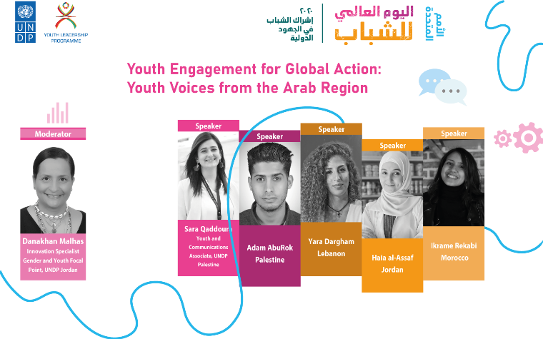
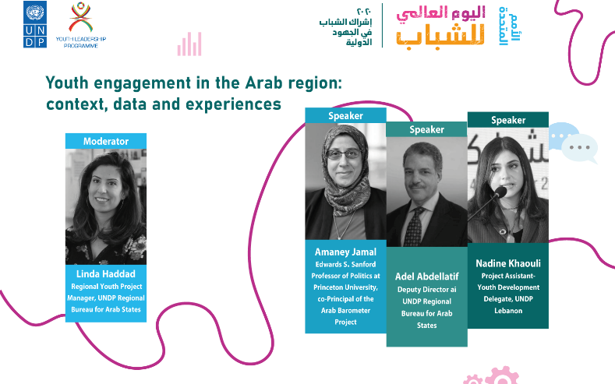

2. UNDP Youth Futures Fellowship

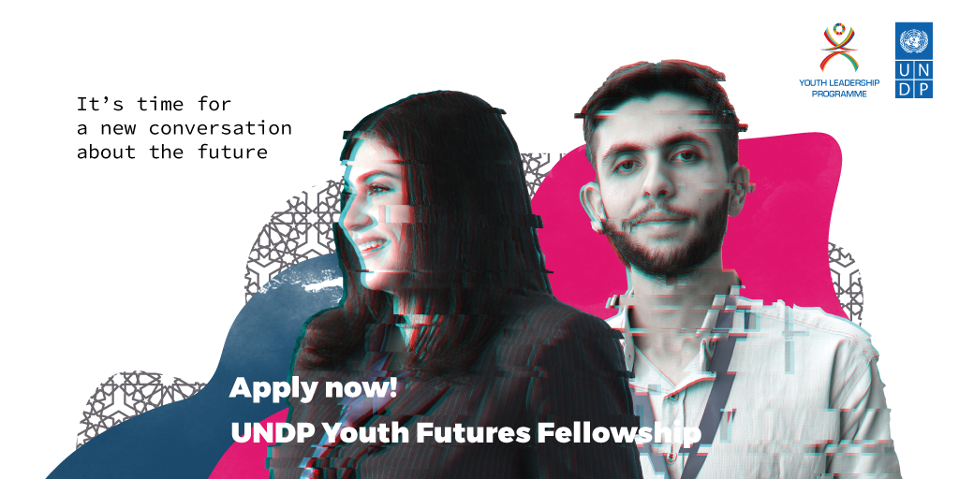

In October 2020, a participatory futures exercise was launched involving young people in the Arab States region and their imaginings of the futures of climate action and civic engagement. 32 young people, from 15 Arab countries were selected from among over 400 creative works, to partake in a 7-week online fellowship programme on futures thinking. The programme content included capturing and analysing signals of change, exploring future scenarios, and participatory futures methodologies. In their final projects, the fellows will be developing innovative ways of engaging their own communities in thinking about the future. For UNDP, the fellowship provided an opportunity to innovatively capture young people’s narratives and aspirations about the future as an input for country and regional-level programming.

3. Mentorship Programme Development – As it became crucial to work towards identifying new entry points to further develop the leadership talent among the participants, strengthen their capacity, knowledge and experience and contribute to increasing wider social impact, a need for region-wide Mentorship offer was identified. Given the new global circumstances related to COVID-19 pandemic and the work conducted on creating the Next Gen Youth Platform, the Regional Youth Team, with collaboration with Youth Development Delegates has taken on a new approach in forming a proposal for YEEP’s Mentorship offer. Accessible through the Mentorship Portal nested within the Next Gen Youth Platform, the registration, matching process and evaluation will be completed through the online portal, while the mentors and mentees can choose their preferred mode of communication, providing efficient and structured processes.

4. YLP6 Regional Forum – (24 – 27 November 2020)

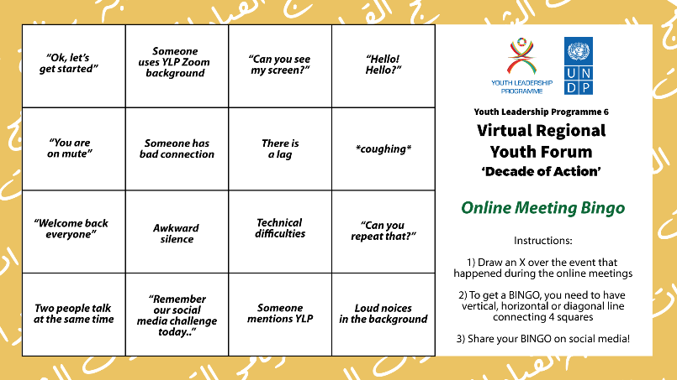
This four-day virtual event brought together around 200 participants, including selected youth that took part in YLP6 activities, representatives of youth-serving organizations from the region, youth Focal Points from UNDP Country Offices, as well as YLP alumni. Inspirational speakers, technical experts from the region and young leaders looked into innovative ways to approach social entrepreneurship as well as explore the three main focus areas of YLP6: climate action, civic and political participation, and pandemics.

The pitching session for the youth to the panel of experts have given the participants exposure to the expertise of UNDP personnel, entrepreneurial and thematic experts as well as experience in presenting and improving their social innovation ideas, strengthening their capacity in creating social change in their communities.

5. Hope Campaign (March 2021)

The pandemic has opened up the discussion on mental health across the globe, and need for information, connection and safe places for discussion has become more evident. In this framework, UNDP RBAS Regional Youth Team, and the Youth Development Delegates from 11 countries in the Arab States region developed a regional online campaign in March to share tips and stories related to moments of demotivation and finding hope. The campaign encouraged youth to discuss mental health and coping mechanisms, a topic that is not usually openly discussed in the region. It combined fact-based information with sharing of personal experiences. The Youth Development Delegates shared their experiences and insights through video messages to encourage discussion and reflections.

YLP 7 Regional Workshop (25th May – 2nd June 2021) - a 7- day regional event launching the 7th edition of the Youth Leadership Programme focused on knowledge exchange, sharing of good practice and capacity building towards project’s four pathways: entrepreneurship, community building, policy shaping and job seeking. The workshop was attended by representatives of over 90 youth-serving organizations, national ministries, student associations, youth clubs and YLP alumni from 16 Arab countries. Held from 25th May to 2nd June the event attracted a total of 250 participants, attending sessions delivered by experts, entrepreneurs, policymakers, and youth from regional and national organizations based in Tunisia, Palestine, Somalia, Lebanon, Sudan, Libya and Egypt, as well as speakers and experts from the African and South Asian regions.

6. International Youth Day (12th August 2021)

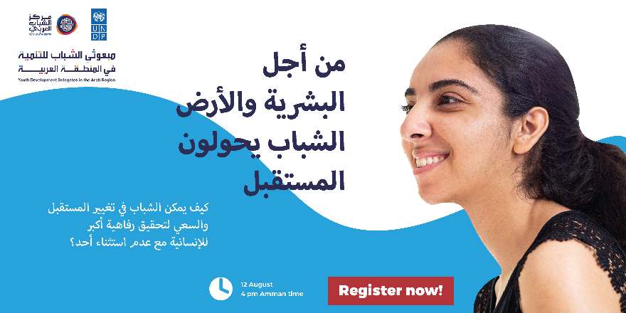
Organized by the Youth Development Delegates from 10 Arab Countries, a day of engaging talks and interactive sessions where experts and young changemakers shared their knowledge and discussed together topics related to individual, community, and planetary wellbeing. The panel was composed of experts from Lebanon, UAE, Bahrain, Somalia, Yemen, Palestine, and Tunisia. Held on 12th August, the event attracted 350 participants from the Arab region, reaching 1,000 views on Facebook live.

7. Roundtable event between Arab Youth Center, United Nations Development Programme and Youth Development Delegates (1st September 2021)

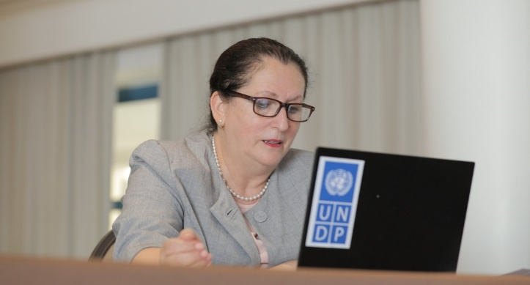
As the Arab Youth Center agreed to fund a second year of the Youth Development Delegate Programme based on the success of 2020, the signing of the financial agreement has been followed that up a virtual event that took place to officially launch the second year of the AYC-UNDP partnership. The Youth Development Delegates were invited to join with H.E. Shamma Sohail F. Al Mazrui, Minister of Youth, Vice Chairman of Arab Youth Center and Dr. Khalida Bouzar, Assistant Administrator and Regional Director for the Regional Bureau for Arab States to discuss their experience over the year they have spent working in UNDP Country Offices, working on youth programming.

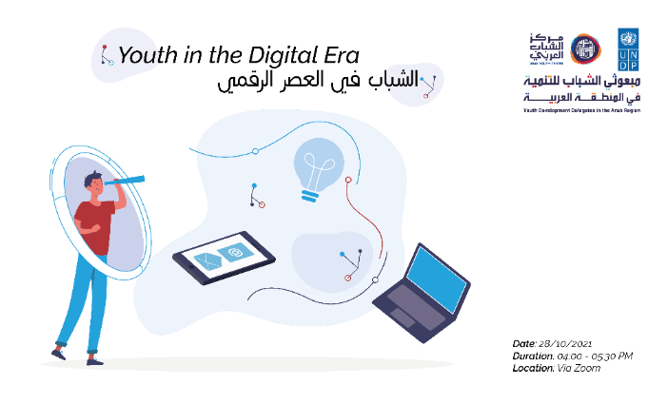
8. Youth in the Digital Era (28th October 2021)

Organized and facilitated by the Youth Development Delegates from Lebanon, Bahrain, Syria, and Tunisia, inviting regional specialists and experts on cryptocurrency, digital transformation, and new technologies to discuss the role digital technologies play in our everyday life as well as in work environment. Held on 28th October and delivered fully in Arabic, the webinar was attended by 107 participants on Zoom and watched by 589 viewers on Facebook live.

9. YLP7 Regional Youth Forum (24th – 25th November 2021)

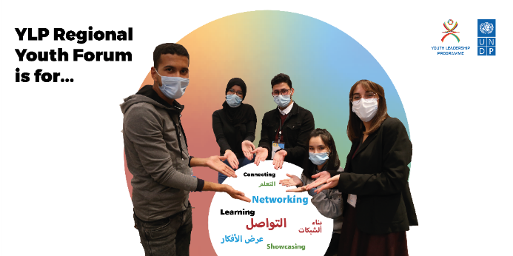
This two-day event took place in November, concluding 7th edition of Youth Leadership Programme. A number of workshops and sessions were held online on regional level, as well as in-person on national level in some countries, with over 300 youth and partners from 15 countries. The sessions provided opportunity for region-wide discussion on how to be a changemaker, deal with adversity in difficult situations and interconnectedness of Sustainable Development Goals as well as networking sessions for the youth and partners to exchange experiences and stories with those from other countries.

10. Jordan Social Entrepreneurship Summit (29th-30th November 2021)

The Youth Project supported the planning and organization of the first annual Jordan Social Entrepreneurship Summit. The Summit gathered 250 participants in-person and online: key experts, social impact networks, impact investors, youth agents, social entrepreneurs, and policy makers to exchange ideas, best practices and to learn about and advance the development of social entrepreneurship sector in Jordan. More than 40% of the participants were youth, and ten Jordanian youth start-ups presented their projects during the Summit and were awarded the 1st Social Entrepreneurship Award. Two of these youth were YLP alumni.
11. International Volunteer Day (16th December 2021)

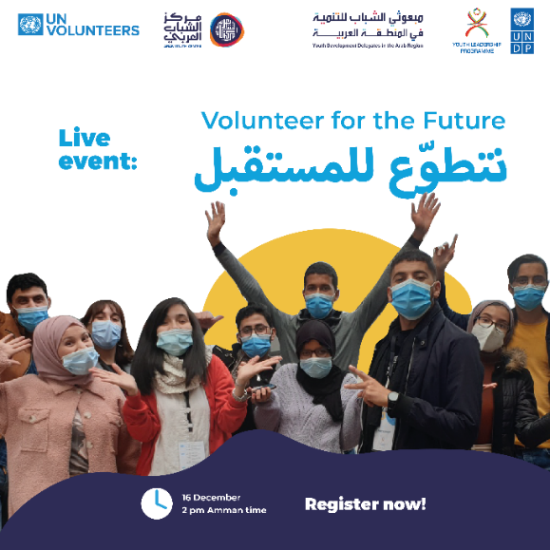
In order to celebrate the accomplishments of young volunteers in the region, and building on last year’s International Volunteers’ Day theme, “Volunteer now for our common future”, Youth Development Delegates and YLP alumni in partnership with the Arab Youth Center and UN Volunteers organized “Volunteer for the Future “ webinar. The webinar showcased different volunteering efforts in the Arab Region, inspiring young changemakers to take action towards the development of their countries and region at large, explained the linkage between volunteering and the global agenda and highlighted the great impact volunteering can contribute towards the SDGs. The event took place on 16th December, attracting 150 participants on Zoom and 976 views on Facebook live.

12. Development of Curricula –In order to successfully implement YEEP and support project’s pillar related to capacity strengthening, a series of curricula focused on developing skill sets and knowledge of the youth is being developed. Three curricula on 1) Climate Change and Environment Awareness and Mainstreaming, 2) Youth Civic and Political Participation and 3) Emotional Intelligence and Leadership Skills have been underway since September 2020. They are in the final stages of development and will be translated and published in O1 of 2021. The development process has been inclusive and cooperative, including a collaborative regional stakeholder Needs Assessment Survey, several consultations with Country Offices, partners, and youth as well as close follow up from the Regional Youth Team, Climate Team and Electoral Team for respective curricula. The final products are to be used by local youth-serving organizations that work with youth on the ground.

13. Donor Mapping Exercises – Two in-depth donor mapping exercises took place in 2020, one in consultation with RBAS Partnerships Advisor Nada Bouari and one following recommendations of good practices from the RBAP Youth Team. First, an in-depth analysis of 5 prioritized member states (EU, Norway, Sweden, Germany, and The Netherlands) identified new entry points, priority thematic areas and geographical focus that helped inform the initial approach to the Nordic Relationship Manager. Following this exercise, the Regional Youth Team identified a need for a larger mapping, targeting specific categories of donors to explore national, global, and regional funding opportunities for projects and initiatives that focus on youth engagement and empowerment. A task force of five UN Online Volunteers was recruited and over five weeks the team developed a detailed list of over 200 potential donors, that will serve as a tool for UNDP RBAS Regional Programme, Country Offices and Youth Leadership Programme partners working on the national level. The mapping process was coordinated and supervised by the Regional Youth Team and Youth Development Delegate Sara Qaddoura.

14. Next Gen Youth Platform - The Regional Youth Team procured an external supplier to create a virtual space in the form of a digital platform that will bring together different elements of an enabling ecosystem together - YLP alumni, national partners including youth serving organizations , donors, incubators, policymakers, academia, external stakeholders, and individuals. The aim is for the website to be a multi-functional platform, that will provide opportunities for networking, capacity building, exchange of knowledge, resources and good practice, connecting youth with experts, other youth across the region, connecting youth-serving organizations with youth and with each other, progress tracking, exposure and showcasing the work done by the youth as well as our national partners . Each country will have an opportunity to showcase progress made on the national level, provide updates on activities, and share announcements and knowledge with their youth - a ‘one-stop-shop’ for anyone engaged with or interested in UNDP Arab States Youth Empowerment and Engagement Programme.

15. YDD Project Proposals - Two youth-led projects were funded through the Youth Development Delegates Programme partnership, a joint initiative between the UNDP and the Arab Youth Center. The Youth Development Delegates who serve at UNDP Country Offices in Lebanon and Somalia were selected through a competitive process for project proposal funding. Both projects target the thematic areas of Covid-19 and youth, with a contextualised approach to it; UNDP Somalia partnered with the UNDP Accelerator Labs to help youth to tell stories about the pandemic, but also about key issues such as water scarcity and the treatment of people with disabilities. UNDP Lebanon and the Youth Leadership Programme developed a youth-led online campaign “Shabab Byehko Covid”, which spread awareness about Covid-19 and fought misinformation spreading on social media through creative videos which reached more than 40k people.

16. Development of donor engagement strategy and engagement of strategic partners -
Annual donor engagement planning, and strategizing was carried out to help guide and focus efforts for resource mobilization. A mapping by external online UNV volunteers was conducted in addition to producing a plan of action with support from the Bureau of Partnerships and External Affairs. . In addition, the project was able to secure funding for youth employment and entrepreneurship activities in six countries from The Big Heart Foundation and the Kingdom of Denmark through the Danish-Arab Partnership Programme (signature pending at the time of this report).

Synergies were sought with ILO and UNICEF to address cross-cutting youth development issues through a provisional regional framework leveraging essential links and complementarities of each agency’s mandate, in particular in areas such as civic and political engagement, and decent work and entrepreneurship. The three agencies have committed to building on existing joint initiatives at the country and regional level (including the Issue-Based Coalition on adolescents and youth) and capitalizing on the comparative advantages of the three agencies, joining their respective adolescent and youth agendas. ILO and UNPD are in the process of formalizing collaboration on jointly exploring the impact of war and fragility on labour markets and governance, analysing root causes of conflict and developing development options and recovery pathways at the HDP nexus.

17. Support to Country Offices on Youth Programming – During the initiation period a tailored, context-specific support was provided to national youth focal points in Country Offices by assigned Regional Youth Team members, each working with a group of 5 countries throughout the year (grouped into three groups: 1) Bahrain, Lebanon, Tunisia, Egypt, Somalia; 2) Morocco, KSA, Palestine, Djibouti, Algeria; 3) Jordan, Iraq, Syria, Yemen, Libya). To strengthen the youth programme delivery on the ground a needs assessment was conducted that in Q1 of 2021, collecting requests from COs and the Regional Youth Team responded in order to meet those needs: external experts, speakers and trainers, technical colleagues from RBAS, as well as from Country Offices were invited to deliver context-specific training on topics related to gender equality, climate change, political and civic participation, SDG implementation and Design Thinking. The needs were also responded to through an ongoing series of internal capacity strengthening webinars targeting country office youth programming staff and partners, including both sharing of best practices and external expertise on topics such as use of the donor mapping database, digital wellbeing, engaging support structures of UN Volunteers and more.

18. Youth Project Development - The project team conducted consultations with a cross-section stakeholder in an effort to co-create a broad vision for youth development in the region that is grounded in the realities of young people and carried by relevant actors to drive an ambitious agenda for addressing the systemic framework conditions that impede young people in positive agents of social and economic change. Stakeholders included technical colleagues at the Regional Hub, Regional Programme colleagues included, YEEP partners in Country Offices as well as partner youth-serving organizations, youth Focal Points as well as with the Youth Development Delegates at the Country Office level. The team also consulted with external stakeholders and potential partners such as UNICEF, ILO, SPARK, i4policy foundation, and SMART Africa. Together with technical colleagues at UNICEF and ILO, building on existing joint initiatives and in line corporate collaboration frameworks, the project team agreed on a shared agenda to promote young people’s empowerment by building their capabilities and creating access to opportunities for engagement. Bringing together governments, private sector partners, civil society, and young people, not only to provide education and training relevant to social and market conditions but also to support national and local actors to create spaces where millions of young people can evolve and contribute meaningfully. It will address inequities in reaching development targets through intentionally and strategically bringing the voices of the most marginalized into the process of visioning, strategizing and action.

The proposed 5-year joint project constitutes a demonstration model and is part of a 9-year phased framework with the same timeline of the SDG Agenda. Placing Youth at the center of implementing the SDGs as partners, this approach is aimed at laying the foundation for innovation and scale in the incremental development of policies, systems, capacities and monitoring and evaluation systems. Young people’s voices are expected to be firmly placed at the center of all decisions impacting their lives.

The conceptual offer was endorsed by Regional Hub management in early January 2020, a project document was submitted for PAC December 2021.

19. Social Media and Communication Efforts

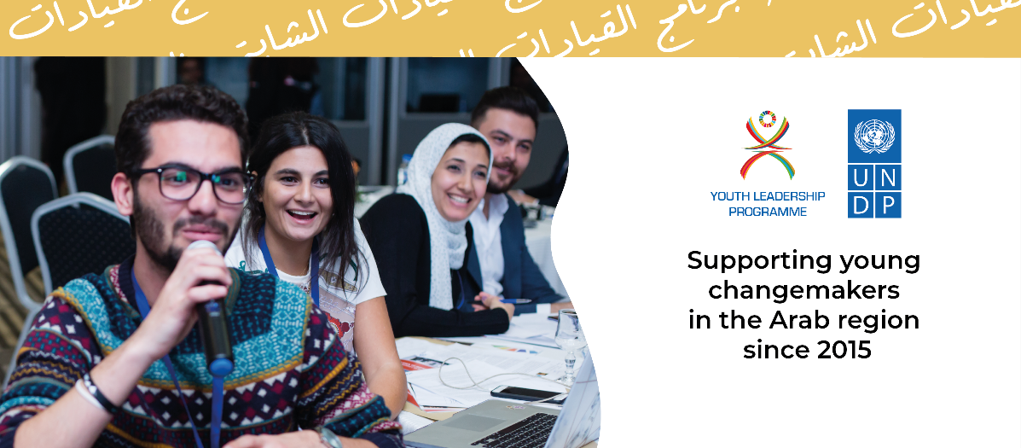

The Youth Project communications and social media activities served to support outreach and engagement to youth and partners. The content on social media channels aimed to

  - Share knowledge about YLP, YDD and other youth programming, and share impact and learning outcomes
  - Engage youth and partners and create a feeling of a network and community

The social media channels used include Facebook, Instagram and Twitter. In addition, the Youth Project had several online spaces where content was published, including the UNDP RBAS website, and the UNDP RBAS newsletter. Social media channels also offer a chance for youth to connect with the YLP team via private messages, where they can ask questions or propose suggestions for the online content. Through direct messaging, the YLP team keeps direct contact with the youth and shares information and knowledge. During the year, the team has corresponded with thousands of youth via Facebook and Instagram.

The regular content consisted of event and campaign content, sharing learning opportunities available for youth (e.g. competitions, hackathons and other learning opportunities), webinars, commemorating international days (as recognized by the UN), thematic content linked to raising awareness of SDGs, and sharing content from global UNDP campaigns.

In addition, several content series/campaigns were launched:

YLP Country Takeovers (2020-2021) gave a space to the UNDP Country office youth staff to take over YLP regional social media accounts for one day and showcase the national level achievements, teams and youth participants or alumni. These takeovers aimed to increase collaboration between regional and national level teams and share behind-the-scenes look at YLP in different countries for youth audiences. | 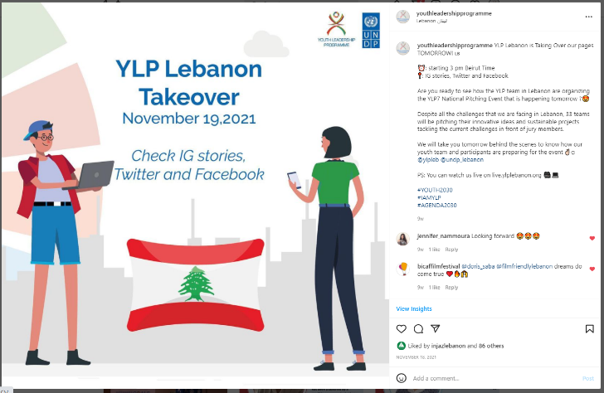
World Mental Health Day (10th Oct) was celebrated both 2020 and 2021.  In 2020, one-day campaign #SayItOutLoud encouraged youth to discuss mental health issues more openly and offered a space for peer-to-peer connections and solidarity.  In 2021, the campaign continued in similar sentiment, encouraging youth to create safe spaces for each other to express their feelings. The campaign also invited youth to share stories anonymously related to issues that are challenging their mental health. These stories were analysed thematically, and two key themes were identified: economic situation and self-confidence. To discuss these topics, experts from Fadhfada project run by UNDP Syria were invited to an online discussion which was recorded and shared as videos in December 2021-January 2022. In addition, YLP alumni shared their experiences together with the experts as a form of peer-to-peer support. | 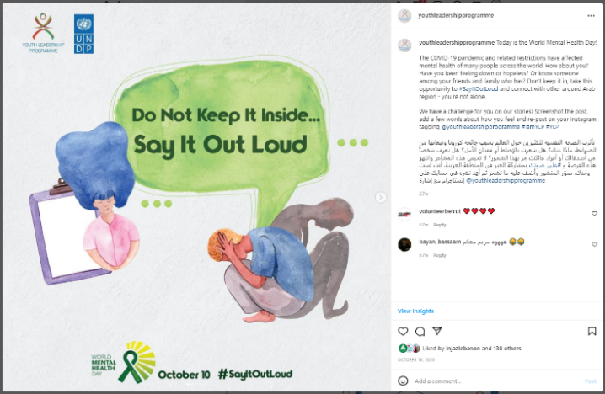  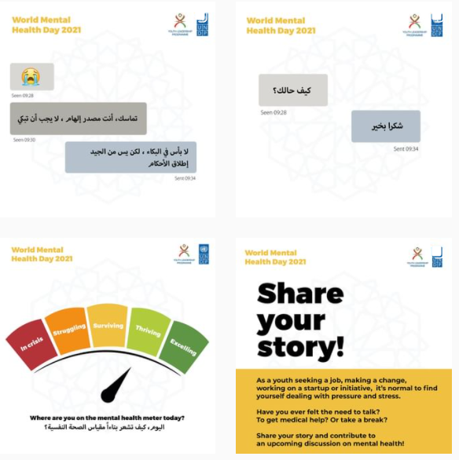
Hope Campaign (March 2021) – The pandemic has opened up the discussion on mental health across the globe, and need for information, connection and safe places for discussion has become more evident. In this framework, UNDP RBAS Regional Youth Team, and the Youth Development Delegates from 11 countries in the Arab States region developed a regional online campaign in March to share tips and stories related to moments of demotivation and finding hope. The campaign encouraged youth to discuss mental health and coping mechanisms, a topic that is not usually openly discussed in the region. It combined fact-based information with sharing of personal experiences. The Youth Development Delegates shared their experiences and insights through video messages to encourage discussion and reflections. | 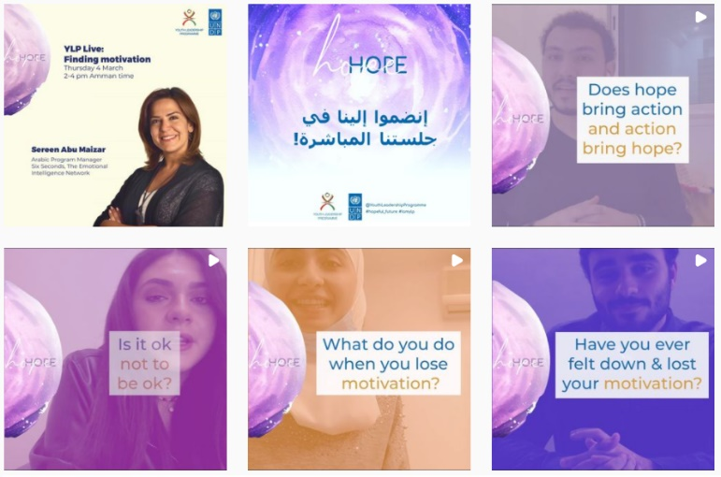

Between July 2020 and December 2021, 1818 posts, tweets and stories were published on YLP social media channels, which gathered 1 619 034 organic views. At the end of 2021, YLP social media channels had 42 231 followers. During the reporting period, the number of followers grew by 16011, which represents a 61% growth. In addition, the published content kept a solid engagement rate of 4.5%, which is significantly higher than the global NGO average of 0.5%. No sponsored posts or ads were used to gain more followers or views.

You can see more detailed analysis of each social media channel in Annex III on page 28.

In 2021, social media remains the main channel to reach and engage with youth, and these numbers both showcase the growth of the YLP community, and the level of connectedness and engagement the youth have with the community.
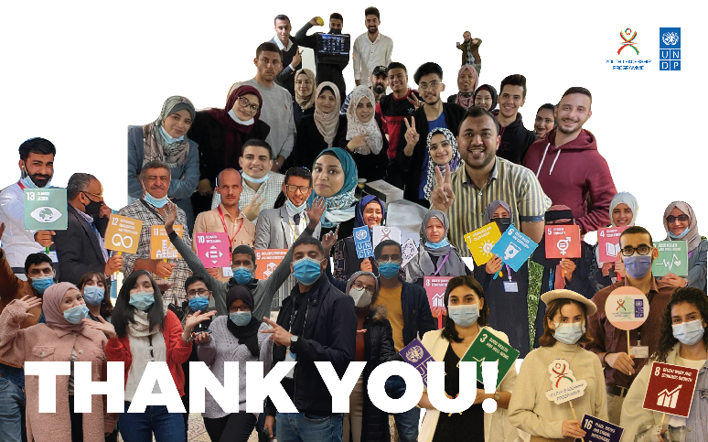
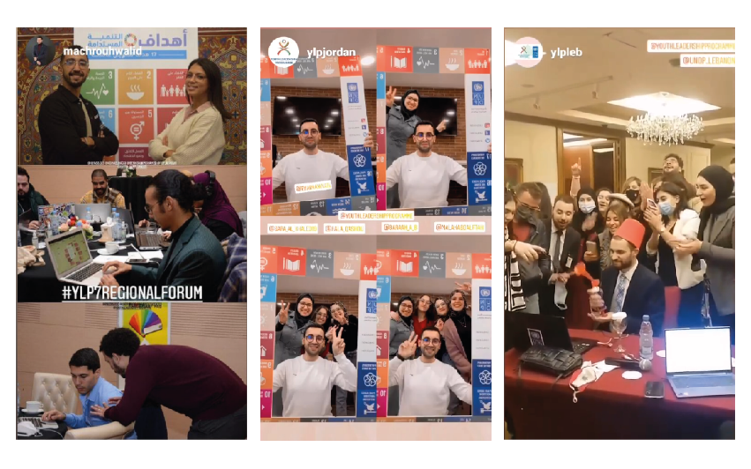
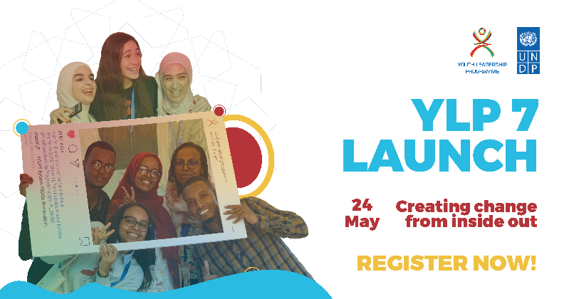
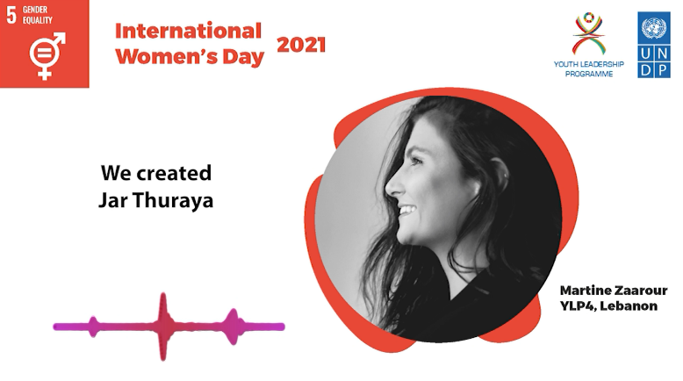
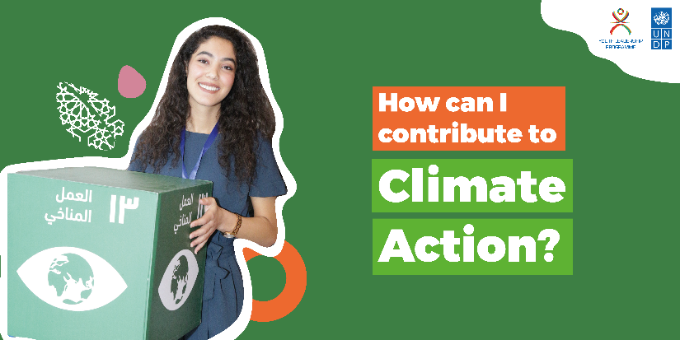
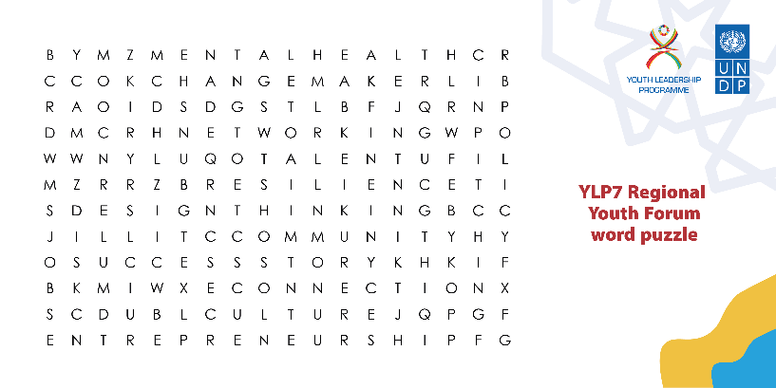

Key Results:

Output 1: Youth and partner networks expanded, and mechanisms institutionalized to create an environment for acceleration of youth innovation and SDGs

1.1 Level of expansion of youth and partner networks: Number of strategic partners mapped and engaged,

platforms expanded, events executed – Regional Youth Team has approached and engaged in discussions with UNICEF and ILO to collaborate together on the launch of the new Regional Youth Project. The project is currently in process to reach financial agreement with The Big Heart Foundation, The Danish-Arab Partnership Programme and Silatech. A financial agreement for another year of funding have been signed with the Arab Youth Center.

An external supplier was procured to build and launch the Next Gen Youth Platform – a virtual space for the youth participants, partners, Country Office staff and external stakeholders. Phase 1 concluded in August 2021 and Phase 2 is currently under way, with launch to take place in March 2022. In the reporting period seven events were executed: International Youth Day competition and panel (August 2020), YLP6 Regional Forum (November 2020), Regional Workshop (May/June 2021), International Youth Day (August 2021), Roundtable x AYC (September 2021), Regional Youth Forum (November 2021), International Volunteer Day (December 2021). Reporting period: 2, 0, 2; Cumulative total: 5, 1, 7

Output 2: Youth Project developed with identified partners and funding

2.1 Project document developed – a number of consultations with technical staff, RBAS personnel, external stakeholders and partner youth-serving organisations were conducted during the reporting period. The project document for the new regional Youth Project has been developed and submitted for PAC. - Reporting period: 1, cumulative: 1

2.2 Number of funding partners engaged through funding agreements – The Regional Youth Team has conducted an in-depth donor mapping exercise and identified potential donors, and The Big Heart Foundation (UAE) and the Arab Youth Center (UAE) were engaged through funding agreements while discussions are taking place with Silatech and The Danish-Arab Partnership Programme. Reporting period: 2, cumulative: 2

Project Output 3: Youth leaders’ capacity strengthened, and their knowledge enhanced

3.1 Number of Country Offices supported on youth programming- The Regional Youth Team provided support in delivery youth programming to 16 Country Offices: Algeria, Bahrain, Djibouti, Egypt, Iraq, Jordan, Lebanon, Libya, Morocco, Palestine, Saudi Arabia, Somalia, Sudan, Syria, Tunisia, and Yemen.

Reporting period: 16, Cumulative: 16

3.2 Level of engagement with and of youth-serving organizations – During the reporting period the staff of the Regional Youth Team provided context-tailored technical support to each Country Office, actively responding to the needs and requests of each youth team on the national level. Technical colleagues from RBAS, as well as from Country Offices were invited to deliver context-specific training on topics related to gender equality, climate change, political and civic participation, SDG implementation, leadership skills and Design Thinking. Additionally, region-wide online training on technical tools and virtual capacity-building, as well as Online Experiential Learning Methods, were provided to all interested partner youth-serving organizations and Youth Focal Points. A knowledge product was developed to aide partners across the region. In 2021 a 7-day workshop focused on capacity building was organized, with sessions delivered by regional and UNDP experts.

Reporting Period: High, Cumulative: High

3.3 Number of curricula developed to support Regional Youth Project – During the reporting period all three consultants were procured to develop the three curricula (1. Emotional Intelligence and Leadership Skills, 2. Climate Change and Environment Awareness and Mainstreaming, 3. Youth Civic and Political Participation), required consultations with target group were conducted and the curricula were delivered in the final English version in Q1 of 2021. Reporting period: 3, Cumulative: 3

- Key Challenges, Lessons Learned and Recommendations

Key Challenges:

The COVID-19 pandemic that forced lockdowns, closures of workplaces, schools, and public places globally in March 2020 have affected the livelihoods of the vast majority of the population across the world. In the Arab region, all countries participating in UNDP youth programming had to move and adapt to an online training delivery in a very short period of time, affecting the ability to reach all target groups. Due to low connectivity issues, the unpredictability of internet connection and lack of access to electronic devices across the Arab region has led to delays in programme delivery as well as the inability of all interested youth to participate, vastly reducing the number of participants compared to previous years. In Sudan, the connectivity issue led the Youth Team to provide specialized training to a small sample of previous YLP participants instead of acquiring a new cohort. In Tunisia, a hybrid approach was adopted, where a mix of online and in-person, socially distanced training was delivered. The remaining countries adopted a new modality of service delivery, moving completely online and utilizing innovative digital tools to engage the youth participants. In order to mitigate this situation, online training for Youth Focal Points and partner youth-serving organizations was provided by the Regional Youth Team. It is recommended that standardized training on online/virtual delivery of youth programming to all Focal Points and partner youth-serving organizations is provided as a part of mandatory pre-activity training.

Lessons Learned

The adverse situation caused by the pandemic in the Arab region has brought to light unexpected positive outcomes for the youth programming: shift to the virtual training delivery resulted in a spike in numbers of participants who declared a disability or access needs in Syria as well as spike in number of female participants across Iraq. As such, the team will discuss ways and methods to provide online training to those who may not be able to attend in-person training due to their circumstances.

Also, the additional human capacity of the designated Youth Development Delegates has significantly improved the quality of youth programming on the ground through regular reporting, creation of context-specific solutions, cross-border collaboration, and close coordination of activities. It is highly recommended to continue the partnership with the Arab Youth Center in order to keep the Youth Development Delegates to support high-quality youth programming at country-office level.

Furthermore, a dedicated, context-specific technical support to Youth Teams in Country Offices offered by designated staff of Regional Youth Team assured relevance, consistency and efficient adaptability resulting in improved youth programming on the ground. It is recommended to continue this modality of technical support provision.

Finally, in order to develop a sound project for youth empowerment in the Arab region, investment was required by the Bureau to support the process. The Regional Youth Team was both delivering on activities, testing portions of the approach that became a part of the new project and engaging in consultations with stakeholders on several levels. This required time, agility, and adaptability.

The 18 months of the initiation plan have been a huge learning experience for the project team and all recommendations stem directly from the challenges faced by the Regional Youth Team, Youth Focal Points, Youth Development Delegates, partner youth-serving organisations and the youth participants.

- Update on risks and mitigation measures

Restrictions and health hazards resulting from the COVID-19 Pandemic have severely impacted the number of participants taking part in youth programming on the national level across the Arb region. All Country Offices and partner youth-serving organizations have been encouraged to take up safety measures to prevent spreading the virus among participants, by moving all programme delivery online in order to practice social distancing. All in-person regional events have been cancelled and travel has been discouraged. In order to enable all partner organizations to deliver youth programming online, a region-wide training on ‘Training Youth Online’ was organized and provided by the Regional Youth Team. Each Country Office Youth Teams and partner youth-serving organizations were provided with access to online tools such as Miro, Zoom and Mentimeter. These measurements were carried out until Q3 of 2021 when some Country Offices were in a position to deliver events and sessions in a hybrid approach.

- Partnerships and Sustainability

SPARK is an INGO with specific expertise in youth employment and SME development with respect to digital livelihoods. This includes training and job placements in the digital sector (as e-commerce, programming, software and mobile app development, digital marketing, graphic design, translation, and data analysis), support to start ups in the GIG sector or for instance SME digitization support (web-based marketing, online payments etc), and support on access to finance, business skills development and curricula development. SPARK is setting up a SME Loan Guarantee Fund in the Middle East. A corporate MoU exists, which the project team will leverage to consolidate a partnership in the areas of youth entrepreneurship training and incubation support.

i4policy Foundation:
#i4Policy is a movement of 200+ innovation hubs from 45 countries who support innovative public policy for innovation. The i4Policy Foundation supports and facilitates inclusive and deliberative national, regional and global policy making processes, dialogue and reforms. i4policy build tools, methodologies and trainings to support common interest formation and public policy co-creation at scale and has developed a crowd-law framework to leverage the best aspects of public participation and deliberation that we call the Innovation for Policy Process. i4policy Foundation has supported the co-creation of policy reform processes in 14 African countries. The project teams have had initial discussions with the aim of partnering with i4policy to train young people and youth serving organizations to deploy co-creation tools, methodologies, protocols and software to facilitate collaboration amongst “policy users” (the people affected by public policy), experts, and policy makers.

SMART AFRICA:
Smart Africa Alliance, which embodies the commitment of African Heads of State to promote affordable access to broadband and ICT in Africa in order to accelerate sustainable socio-economic development on the continent aims to foster conducive framework conditions for technology start-ups as a lever of action for African States, as they can create wealth and jobs, but also improve the efficiency and transparency of the administration, as well as access to basic social services. Preliminary talks have been held to collaborate on policy reform processes.

The Big Heart Foundation:
Consultations took place with The Big Hear Foundation over the course of 2020 and 2021. Funds were secured in 2021 with implementation beginning in 2020 (after the end of this initiation phase). The activities planned for implementation in Lebanon and the State of Palestine will support livelihoods and income generation projects for youth through local NGOs, thereby strengthening local structures and capacities over time.

AYC
During the initiation phase a partnership with AYC was established. The pilot year of 2021 was successful and led to the renewal of an on-going partnership with an annual renewal of the associated financial agreement. The partnership contributes to the work on regional youth empowerment through providing young people with working experience at the UNDP Country Offices. AYC is planning to place additional three youth delegates in Algeria, Libya and Kuwait Country Offices to expand the youth work in the region. The total number of youth working with UNDP country offices supported by AYC is 14.

DAPP
In 2021 the discussions with the Danish-Arab Partnership Programme (DAPP) began to develop a potential partnership with UNDP to deliver a pilot project in four countries in the region: Jordan, Egypt, Tunisia and Morocco. Building on the project previously tested in Denmark, this initiative aims to create green jobs and contribute to green growth in the entrepreneurial sector. The proposal was submitted end of 2021 with expectations that in 2022 an agreement will be signed for UNDP and DAPP to collaborate on working with local stakeholders and key ecosystem actors to support development of youth led SMEs.

Silatech
Consultations with Silatech began in 2021, following a senior level meeting between the RBAS Director and the CEO of Silatech. Discussions continued into the end of the year, with further developments opening a solid opportunity for joint collaboration.

ILO
Discussion with ILO began in 2020 to discuss joint efforts to address youth unemployment in crisis countries. Several rounds of discussions took place and the year 2021 ended with more discussions required. At the working level, there was an agreement to move forward in 2022 is mapping out specific joint collaboration.

- Financial Summary

Table 1: Overview of available resources for the project duration

Donor | Opening Balance | Contribution Received | Available Resources
Arab Youth Center | 0 | 149,078 | 0
TRAC | 0 | 863,449 | 0
Total | 0 | 1,012,527 | 0

Table 2: Overview of allocation and expenditure per output

Output | AYC |  | TRAC |  | Country office contribution | Country office contribution | Total Budget | Total Expenses
 | Budget | Expenses | Budget | Expense | Budget | Expense
Output 1: Youth and partner networks expanded, and mechanisms institutionalized to create an environment for acceleration of youth innovation and SDGs | 149,078 | 149,078 | 220,048 | 220,048 |  |  | 369,126 | 369,126
Output 2: Youth Empowerment and Engagement Project developed with identified partners and funding | 0 | 0 | 409,677 | 409,677 | 6,500 | 6,500 | 416,177 | 416,177
Output 3: Youth leaders’ capacity strengthened, and their knowledge enhanced | 0 | 0 | 181,724 | 181,724 | 45,500 | 45,500 | 227,224 | 227,224
Total | 149,078 | 149,078 | 811,449 | 811,449 | 67,000 | 67,000 | 1,012,527 | 1,012,527

- ANNEXES

Annex I: Progress Review: detailed matrix of activities and results

Output 1 | Indicators |  | Baseline | Annual target | Progress / target
Youth and partner networks expanded, and mechanisms institutionalized to create an environment for acceleration of youth innovation and SDGs  Budget:  Expenditure to date: | 1.1 Level of expansion of youth and partner networks:  Number of strategic partners mapped and engaged, platforms expanded,  events executed |  | 0, 1, 2 | 10, 1, 3 | 2,1,6
Planned activities |  | Results
1.1 Map key strategic partners at the regional and country level |  | Two donor mapping exercises were conducted and concluded in 2020. First one, delivered by UNV Donor Mapping Task Force, resulted in over 200 global, regional, and national funding opportunities identified and donors mapped, Additionally, an in-depth key strategic partner mapping was conducted by the Regional Youth Team and the information gathered will feed into the briefing notes for donor meetings.
1.2 Design and create mentorship programme  (building off of 2019’s proposal) |  | Upon consultations conducted with the UNDP colleagues, youth and Youth Development Delegates, a Mentorship Programme Proposal was drafted and is awaiting the development of phase 2 of NextGen Youth Platform implementation.
1.3 Support National Youth -Serving Organizations by enabling them to deliver YLP programming virtually |  | In 2020 two region-wide online trainings on technical tools and virtual capacity-building as well as Online Experiential Learning Methods were re provided to enable partner organizations, Focal Points and Youth Delegate to deliver interactive, engaging, and experiential online learning and capacity building to the youth participants. In 2021 a 7-day workshop focused on capacity building was organized, with sessions delivered by regional and UNDP experts.
1.4 Develop further an online support networking, and enabling platform for youth and all partner |  | The Next Gen Youth Platform is currently under development of Phase 2, Phase 1 concluded in August 2021 and will launch in Q1 of 2022.
1.5 Supporting youth engagement in COVID-19  response |  | Two country- level projects related to youth and COVID-19 response were funded and delivered in Lebanon and Somalia in 2020.
1.6 Recruit youth development delegates + organize induction ceremonies |  | 10 Youth Development Delegates and 1 Youth Delegates Coordinator were recruited and placed in Country Offices as well as at the Regional Hub and an online Induction Ceremony in lieu of in-person meeting was organized in online. In Q1 of 2021 AYC agreed to extend the cohort for an additional year based on the success of 2020.

Output 2 | Indicators |  | Baseline | Annual target | Progress / target
Youth Empowerment and  Engagement Project developed with identified partners and funding  Budget:  Expenditure to date: | 2.1 Project document developed |  | 0 | 1 | 1
 | 2.2 Number of funding partners engaged through funding agreements |  | 0 | 1 | 2
2Planned activities |  | Results
2.1 Consultations with stakeholders to shape vision of new project |  | A number of extensive consultations were conducted with the key stakeholders to shape the vision of the new project, including youth, Country Offices, youth-serving organizations, other UN agencies such as ILO and RBAS technical teams.
2.2 Develop new branding and communications  material |  | New branding and communication materials were developed to expand the reach of the project on social media as well as accommodate the expansion of the regional project itself.
2.3 Produce comparative analysis and overall  theory of change, and project document |  | As a result of consultations, desk research and technical feedback from UNDP RBAS and Global colleagues the team developed theory of change and a project document.
2.4 Engage in consultations with funding partners on YEEP design and funding |  | The YEEP team engaged with The Big Heart Foundation, Arab Youth Center and Danish-Arab Partnership Project to discuss funding, design and implementation of project’s activities on the ground.

Output 3 | Indicators |  | Baseline | Annual target | Progress / target
Youth leaders’ capacity  strengthened, and their knowledge enhanced  Budget:  Expenditure to date: | 3.1 Number of Country Offices supported on youth programming |  | 10 | 16 | 16
 | 3.2 Level of engagement with and of youth serving  organizations |  | Moderate | High | High
 | 3.3 Number of curricula developed to support YEEP |  | 0 | 3 | 3
Planned activities |  | Results
3.1 Support to Country Offices on youth programming |  | External experts, speaker and trainers, technical colleagues from RBAS, as well as from Country Offices were invited to deliver context -specific training on topics related to gender equality, climate change, political and civic participation, SDG implementation and Design Thinking. A tailored, context-specific support was provided to national youth focal points by assigned Regional Youth Team member, working with a group of 5 countries throughout the year.
3.2 Organize the Launch of YEEP March 2021 |  | The Regional Launch and Workshop took place in June 2021 over 7 days and gathered over 200 participants.
3.3 Develop curricula for next generation YEEP  + training of trainers on the curricula |  | Three curricula have been developed on 1) Emotional Intelligence and Leadership Skills; 2) Climate Change and Environment Awareness and Mainstreaming; 3) Youth Civic and Political Participation Curriculum. EI & Leadership skills were tested with a groups of youth from across the region while the Climate Change curricula were tested with youth in Jordan.
3.4 Organize UNDP Arab States Youth Futures  Fellowship: #NextGenNormals |  | The Youth Futures Fellowship has engaged 32 young people from 16 countries across the region in an activity aimed at utilizing innovative tools, such as Foresight, to ideate new ways to engage youth in the future of the Arab region. 7 group projects have put forward ideas that can be utilized by UNDP COs in strategic planning.

Annex II: Updated Risk Log

Risks | Mitigation Measures
Deliverable time of the research products depends on available resources and country-office responses.  Delivery of youth-focused livelihoods and entrepreneurship support (post-COVID19 livelihoods response) through NGOs  Ongoing pandemic crisis  Preparation for the launch of the new youth project for 2022. Secure buy-in and funding partners, from pilot countries for the new youth project | Youth team will make sure to follow up with Cos and other partners in a timely manner to ensure access to resources for the research.  Youth team will negotiate the deliverables in line with the priorities set.  UNDP team will monitor the situation and plan accordingly. Virtual activities will be organized until the situation is safe.  UNDP Youth Team will be exerting a lot of effort to secure both partners and funding guided by careful strategic planning and donor engagement.

Annex III: Social Media Engagement Statistics for the Reporting Period

 | Facebook |  |  |  |  |  |  |  |  |  |  |  | Instagram |  |  |  |  |  |  |  |  |  |  | Twitter
 | Likes | Growth |  | G% | Posts |  | Page reach |  | Post reach |  | Engage-ment |  | Likes | Growth |  | G% | Posts |  | Stories |  | Reach |  | Engage-ment | Likes | Growth | G% | Tweets | Reach | Engage-ment
Jul-20 | 21355 |  |  |  | 19 |  | 38460 |  | 43695 |  | 2.3% |  | 1917 |  |  |  | 13 |  | 20 |  | 9070 |  | 3.1% | 2948 |  |  | 20 | 18009 | 5.0%
Aug-20 | 22867 | 1512 |  | 7.1% | 31 |  | 72633 |  | 93887 |  | 2.2% |  | 2126 | 209 |  | 10.9% | 16 |  | 62 |  | 12208 |  | 7.4% | 3045 | 97 | 3.3% | 56 | 50540 | 3.0%
Sep-20 | 23672 | 805 |  | 3.5% | 15 |  | 68835 |  | 25941 |  | 2.0% |  | 2217 | 91 |  | 4.3% | 8 |  | 74 |  | 4704 |  | 6.5% | 3087 | 42 | 1.4% | 11 | 8697 | 2.9%
Oct-20 | 24769 | 1097 |  | 4.6% | 27 |  | 49685 |  | 69897 |  | 2.6% |  | 2442 | 225 |  | 10.1% | 17 |  | 189 |  | 14586 |  | 9.3% | 3168 | 81 | 2.6% | 28 | 25090 | 4.0%
Nov-20 | 26238 | 1469 |  | 5.9% | 22 |  | 68835 |  | 88523 |  | 2.9% |  | 2661 | 219 |  | 9.0% | 11 |  | 118 |  | 11390 |  | 8.7% | 3298 | 130 | 4.1% | 98 | 82752 | 3.2%
Dec-20 | 27366 | 1128 |  | 4.3% | 21 |  | 50484 |  | 54229 |  | 3.1% |  | 2671 | 10 |  | 0.4% | 14 |  | 9 |  | 9193 |  | 6.6% |  |  |  | 8 | 4215 | 2.6%
Jan-21 | 28234 | 868 |  | 3.2% | 3 |  | 13640 |  | 9824 |  | 2.8% |  | 2662 | -9 |  | -0.3% | 1 |  | 13 |  | 595 |  | 17.0% | 3336 | 38 | 1.2% | 2 | 989 | 3.0%
Feb-21 | 28874 | 640 |  | 2.3% | 18 |  | 17306 |  | 26407 |  | 3.3% |  | 2687 | 25 |  | 0.9% | 11 |  | 19 |  | 6415 |  | 9.8% |  |  |  | 5 | 5553 | 1.2%
Mar-21 | 29873 | 999 |  | 3.5% | 19 |  | 58748 |  | 91457 |  | 3.1% |  | 2744 | 57 |  | 2.1% | 13 |  | 37 |  | 13932 |  | 6.5% |  |  |  | 12 | 10336 | 1.6%
Apr-21 | 30194 | 321 |  | 1.1% | 13 |  | 23911 |  | 29093 |  | 2.9% |  | 2873 | 129 |  | 4.7% | 10 |  | 22 |  | 10697 |  | 6.1% |  |  |  | 29 | 13104 | 3.0%
May-21 | 30760 | 566 |  | 1.9% | 18 |  | 45542 |  | 62082 |  | 3.8% |  | 2974 | 101 |  | 3.5% | 10 |  | 3 |  | 3832 |  | 11.0% |  |  |  | 40 | 47798 | 3.1%
Jun-21 | 30938 | 178 |  | 0.6% | 19 |  | 35353 |  | 41813 |  | 1.6% |  | 3311 | 337 |  | 11.3% | 11 |  | 43 |  | 11013 |  | 7.1% |  |  |  | 18 | 20558 | 1.9%
Jul-21 | 31246 | 308 |  | 1.0% | 9 |  | 25685 |  | 28030 |  | 2.0% |  | 3404 | 93 |  | 2.8% | 9 |  | 16 |  | 8697 |  | 8.1% |  |  |  | 6 | 5635 | 3.5%
Aug-21 | 31550 | 304 |  | 1.0% | 10 |  | 38738 |  | 44711 |  | 2.1% |  | 3513 | 109 |  | 3.2% | 6 |  | 19 |  | 8544 |  | 7.3% |  |  |  | 13 | 19267 | 2.8%
Sep-21 | 31870 | 320 |  | 1.0% | 9 |  | 34009 |  | 33122 |  | 1.7% |  | 3613 | 100 |  | 2.8% | 5 |  | 21 |  | 6330 |  | 7.0% |  |  |  | 13 | 7842 | 2.1%
Oct-21 | 32335 | 465 |  | 1.5% | 20 |  | 210120 |  | 61799 |  | 1.8% |  | 3643 | 30 |  | 0.8% | 15 |  | 73 |  | 10589 |  | 6.6% |  |  |  | 27 | 15681 | 3.1%
Nov-21 | 33363 | 1028 |  | 3.2% | 32 |  | 472724 |  | 170767 |  | 2.3% |  | 3984 | 341 |  | 9.4% | 26 |  | 113 |  | 37083 |  | 6.6% | 3964 | 628 | 18.8% | 42 | 26912 | 4.1%
Dec-21 | 33944 | 581 |  | 1.7% | 15 |  | 431878 |  | 86307 |  | 2.9% |  | 4287 | 303 |  | 7.6% | 8 |  | 6 |  | 9654 |  | 8.1% | 4000 | 36 | 0.9% | 9 | 5940 | 3.7%
2020-21 Total |  | 12589 |  | 59% | 320 |  | 1756586 |  | 1061584 |  |  |  |  | 2370 |  | 124% | 204 |  | 857 |  | 188532 |  |  |  | 1052 | 36% | 437 | 368918
Avg per month |  |  |  |  | 27 |  | 146382 |  | 88465 |  | 2.5% |  |  |  |  |  | 17 |  | 71 |  | 15711 |  | 7.9% |  |  |  | 36 | 30743 | 3.0%
 |  |  |  |  |  |  |  |  |  |  | *0.15% NGO average |  |  |  |  |  |  |  |  |  |  |  | *1.37% NGO average |  |  |  |  |  | *0.05% NGO average
Total posts & stories |  |  |  |  |  | 1818
Total reach  (posts) |  |  |  |  |  | 1619034
Average engagement  rate |  |  |  |  |  | 4.5% |  |  |  | Follower growth |  |  |  |  |  |  |  |  |  | 16011
Total followers |  |  |  |  |  | 42231 |  |  |  | Growth % |  |  |  |  |  |  |  |  |  | 61%

Engagement rate a metric that measures the amount of interaction social content earns relative to reach or other audience figures.
https://www.socialinsider.io/blog/social-media-industry-benchmarks/

